Assignment - Operators and Functions

25-04-2023

Q1) Find out the full name of the player with the maximum and

minimum salary.

Ans.

SELECT CONCAT(FIRSTNAME, LASTNAME) AS FULL_NAME, SALARY FROM PLAYER

WHERE

SALARY=(SELECT MAX(SALARY) FROM PLAYER)

OR SALARY=(SELECT MIN(SALARY) FROM PLAYER);

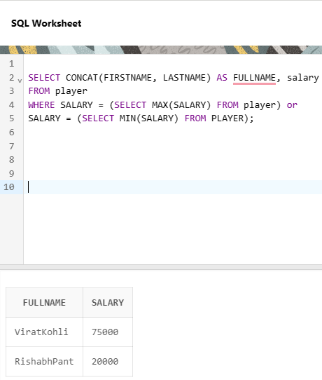

Q2) Find out the salary of the player with the ManagerID 1 and who is a

Wicketkeeper.

Ans.

select salary, firstname

from player

where managerid=1 and RESPONSIBILITY='WicketKeeper';

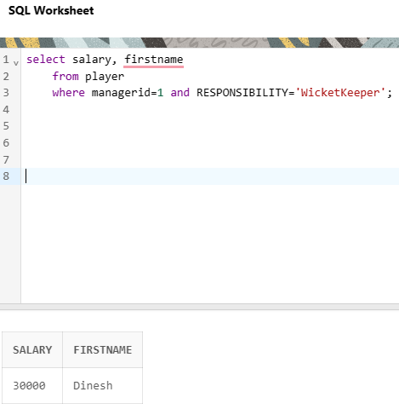

Q3) Fetch details of players who DO NOT belong to the state of

'Bangalore' AND who have a salary that is more than 50000.

ANS.

SELECT * FROM PLAYER

WHERE

STATE <>'Bangalore' AND SALARY > 50000;

Q4) List the SUM of salaries of all players manager-wis

Ans- SELECT MANAGERID, SUM(SALARY) AS TOTAL_SALARY FROM PLAYER

GROUP BY MANAGERID;

Q5) Find AVERAGE salary of all batsmen rounded to 2 decimal places.

Ans.

SELECT ROUND(AVG(SALARY), 2) AS AVERAGE_SALARY

FROM PLAYER

WHERE RESPONSIBILITY = 'Batsmen';

